Name: _______________________________________________________ Class: ________
2025 TERM I MZIMBA NORTH DISTRICT EXAMINATIONS
BIOLOGY FORM 3
PAPER 1
(100 MARKS)
Date: 8-Dec-2025
Time Allowed: 2hrs
(7:30 am to 9:30am)

INSTRUCTIONS:
- Write your name on top of every page of this paper.
- This paper contains 9 printed pages. Please check.
- Answer all the questions in both sections in the spaces provided.

©MZN-T1-2025

SECTION A (70 marks)
1 a. Define the term “Sampling”
_____________________________________________________________________________________________________________________________________________________(1mark)
b. Figure below shows the tool for sampling. Use it to answer questions that follow.

(i). Identify the tool used for sampling.
_______________________________________________________________________ (1mark)
(ii). Explain any two limitations of using the tool shown above.
__________________________________________________________________________________________________________________________________________________________________________________________________________________________________ (2marks)
c. A form three student wanted to find out the estimated number of chambo fish in a shallow pond using capture –mark-recapture technique. He caught 50 chambos marked them with a white paint on the tail fins and then release them back into the same pond. After 3 days, he made a catch of 50 chambos from the same pond and out of them these, 5 had white paint mark. Use the information to answer the questions that follow.
(i). Calculate the estimated population of chambo fish in the pond.

(3marks)
(ii) Suggest another method that could have been used to determine the population of chambo fish in the same pond.
_______________________________________________________________________ (1mark)
(iii) Explain why he left the marked fish in a pond for three days.
__________________________________________________________________________________________________________________________________________________________________________________________________________________________________ (2marks)
2 a. In an ecosystem, a student split a log of dead wood and she found 1000 termites feeding on it. Soon after she had left, two birds came to pick the termites. Use this information to answer the questions that follow.
(i). Draw a well labelled pyramid of numbers to represent this information

(3marks)
(ii). Why does the pyramid in 2 (a i) have such a shape?
____________________________________________________________________________________________________________________________________________________ (2marks)
b. Describe how a pyramid of biomass is constructed
____________________________________________________________________________________________________________________________________________________ (2marks)
3 a. Define the following processes that take place in water cycle.
- Precipitation _______________________________________________________________________________________________________________________________________ (1mark)
- Infiltration _______________________________________________________________________________________________________________________________________ (1mark)
b. Explain any one point how the following physical factors affect ecosystem.
(i) soil __________________________________________________________________________________________________________________________________________________(2marks)
(ii). Temperature __________________________________________________________________________________________________________________________________________________ (2marks)

c. Explain any two ways of controlling air pollution.
_______________________________________________________________________________________________________________________________________________________________________________________________________________________________(4marks)
d.(i) Define the term “Xerophyte”.
___________________________________________________________________________________________________________________________________________________(1mark)
(ii). Give any two examples of xerophyte plants. __________________________________________________________________________________________________________________________________________________(2marks)
4 a. What are non-biodegradable wastes? ___________________________________________________________________________________________________________________________________________________(1mark)
b. Explain how non-biodegradables can help to spread diseases such as malaria. _______________________________________________________________________________________________________________________________________________________________________________________________________________________________(2marks)
- Figure 2 below shows a transverse section of the leaf. Use it to answer questions that follow.
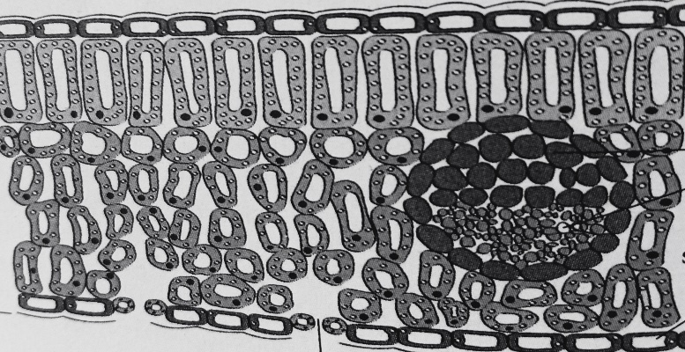
Y
X
Spongy mesophyll
W
Palisade mesophyll

- Identify the parts labeled X and Y
- X______________________________________________________
- Y______________________________________________________ (2marks)

- What a collective name is given to part labeled W
_________________________________________________________________(1mark)

- Write down two structural differences you have observed between palisade mesophyll and spongy mesophyll
________________________________________________________________________________________________________________________________________________________________________________________________________________________________________________________________________________________________ (4marks)

- (i).What would happen to the rate of photosynthesis if the intercellular air space in spongy mesophyll were reduced?
_____________________________________________________________________________________________________________________________________________(1mark)
(ii). Give a reason for your answer. ____________________________________________________________________________________________________________________________________________(2marks)
- Explain any two adaptations of a leaf for photosynthesis.
__________________________________________________________________________________________________________________________________________________________________________________________________________________________________________________________________________________________________________________________________________________________________________ (4marks)
- Figure below is an example of human activities that affect the environment. Use it to answer the questions that follow.

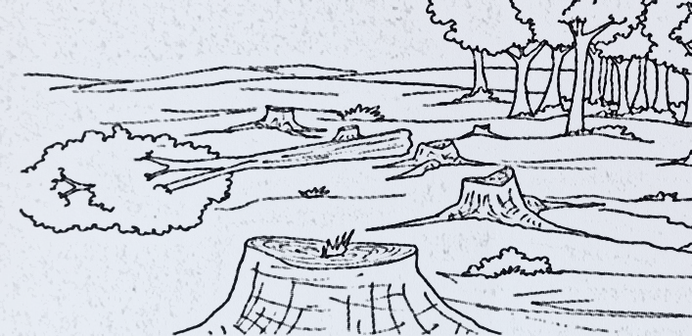
- Identify the activity. ___________________________________________________________( 1mark)

- List any two impacts the activity has on the environment.
__________________________________________________________________________________________________________________________________ (2marks)
- Describe any two ways of mitigating climate change. _________________________________________________________________________________________________________________________________________________________________________________________________________________________________________________________________________________________________________________________________________________(4marks)
- Give any two ways in which Lake Malawi is polluted. _______________________________________________________________________________________________________________________________________________________________________________________________________(2marks)

- Explain any one function of the following mineral elements
- Nitrogen __________________________________________________________________________________________________________________________________(2marks)
- Potassium __________________________________________________________________________________________________________________________________ (2marks)
8a. Explain the functions of the following organelles of a plant cell.
- Cell membrane ____________________________________________________________________________________________________________________________(2marks)
- Mitochondria ____________________________________________________________________________________________________________________________(2marks)

- Define the term “photolysis
_____________________________________________________________________________________________________________________________(1mark)
- What is the main product of photosynthesis? _____________________________________________________________(1mark)
- Explain any two differences between light stage and dark stage of photosynthesis. _____________________________________________________________________________________________________________________________________________________________________________________________________________________________________________________________________(4marks)

SECTION B (30 marks)
- Explain any five adaptations of goats to their habitat. __________________________________________________________________________________________________________________________________________________________________________________________________________________________________________________________________________________________________________________________________________________________________________________________________________________________________________________________________________________________________________________________________________________________________________________________________________________________________________________________________________________________________________________________________________________________________________________________________________________________________________________________________________________________________________________________________________________________________________________________________________________________________________________________________________________________________________________________________________________________________________________________________________________________________________________________________________________________________________________________________________________________________________________________________________________________________________________________________________________________________________________________________________________________________________________________________________________________________________________________________________________________________________________________________________________________________________________________________________________________________________________________________________________________________________________________________________________________________________________________________________________________________________________________________________________________________________________________________________________________________________________________________________________(10 marks)

10. Explain any five fate of glucose after photosynthesis.
______________________________________________________________________________________________________________________________________________________________________________________________________________________________________________________________________________________________________________________________________________________________________________________________________________________________________________________________________________________________________________________________________________________________________________________________________________________________________________________________________________________________________________________________________________________________________________________________________________________________________________________________________________________________________________________________________________________________________________________________________________________________________________________________________________________________________________________________________________________________________________________________________________________________________________________________________________________________________________________________________________________________________________________________________________________________________________________________________________________________________________________________________________________________________________________________________________________________________________________________________________________________________________________________________________________________________________________________________________________________________________________________________________________________________________________________________________________________________________________________________________________________________________________________________________________________________________________________________________________________________________________________________________________________________________________________________________________________________________(10marks)
11. Discuss any five effects of air pollution to the environment. _______________________________________________________________________________________________________________________________________________________________________________________________________________________________________________________________________________________________________________________________________________________________________________________________________________________________________________________________________________________________________________________________________________________________________________________________________________________________________________________________________________________________________________________________________________________________________________________________________________________________________________________________________________________________________________________________________________________________________________________________________________________________________________________________________________________________________________________________________________________________________________________________________________________________________________________________________________________________________________________________________________________________________________________________________________________________________________________________________________________________________________________________________________________________________________________________________________________________________________________________________________________________________________________________________________________________________________________________________________________________________________________________________________________________________________________________________________________________________________________________________________________________________________________________________________________________________________________________________________________________________________________________________________________________________________________________________________________________________________(10marks)End of question paper

